**The Mayo Clinic**

**STAKEHOLDERS**

|  |  |
| --- | --- |
| **ACTOR** | **What he can do on the Software Created** |
| Administrative staff | * Administrative personnel have the ability to monitor patient treatment, assigned physicians, and laboratory services. * Additionally, they have the authority to make decisions based on this data, such as identifying departments in need of improvement or determining which doctors generate the highest revenue |
| Doctors | * Doctors receive patient appointments and can schedule accordingly based on them. * Doctors can electronically send patient test prescriptions through the system, which are received by the laboratory and then directly send the reports back to the doctor via the system, eliminating the need for paper-based processes.Top of FormBottom of Form |
| Nurses | * Nurses receive patient treatment instructions through the Hospital Management System (HMS) and administer treatments accordingly. |
| Senior Management | * Senior management can monitor all hospital activities, including patient history, laboratory revenue, and renowned doctors, among other metrics. |
| Patient | * Patients have the flexibility to book appointments with their preferred doctors from anywhere, and they receive reminders of their appointments via email or SMS one day prior. * Patients receive their final bill through the system upon checking out. |

**Scope**

* The scope of the system encompasses a comprehensive range of functionalities aimed at enhancing the efficiency and effectiveness of hospital operations.
* For administrative staff, it streamlines patient management processes, facilitating easier tracking of patient treatments, assigned physicians, laboratory services, and overall resource allocation. This system empowers administrators to make data-driven decisions regarding departmental improvements and revenue optimization, leading to better resource utilization and overall performance.
* Doctors benefit from streamlined appointment scheduling processes, electronic prescription capabilities, and seamless access to patient records. They can efficiently manage their schedules and patient care, leading to improved workflow and better patient outcomes.
* Nurses receive treatment instructions through the system, enhancing communication and ensuring accurate and timely patient care delivery. This helps in standardizing treatment protocols and improving patient safety.
* Patients enjoy the convenience of booking appointments with their preferred doctors from anywhere and receiving timely reminders via email or SMS. Additionally, they receive their final bills through the system upon checkout, reducing paperwork and improving overall satisfaction.
* Senior management gains comprehensive visibility into hospital activities, including patient history, laboratory revenue, and renowned doctors. This allows for informed decision-making, strategic planning, and effective resource allocation, ultimately contributing to the hospital's success and growth.

**SCOPE using Use Case Diagram (UML)**

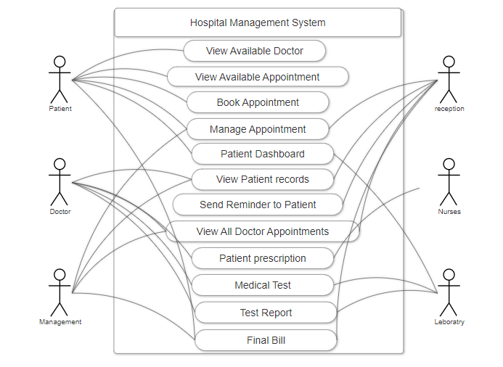

**IN SCOPE**

1. **Patient Management**:

* Registration and profile creation for patients.
* Maintenance of electronic health records (EHR) for each patient.
* Tracking patient demographics, medical history, and treatment plans.

1. **Appointment Scheduling**:

* Online appointment booking for patients with preferred doctors.
* Real-time availability of doctor schedules.
* Automated appointment reminders for patients.

1. **Doctor and Staff Management**:

* Management of doctor schedules and availability.
* Assignment of nurses and staff to patient care duties.
* Tracking of staff performance and workload.

1. **Treatment Administration**:

* Electronic prescription management for doctors.
* Nurses' access to treatment instructions and patient records.
* Integration with pharmacy for medication management.

1. **Laboratory Integration**:

* Electronic ordering of laboratory tests by doctors.
* Direct transmission of test requests to the laboratory.
* Delivery of test results to doctors and patients through the system.

1. **Billing and Financial Management**:

* Generation of invoices and billing statements.
* Integration with insurance systems for claims processing.
* Tracking of revenue, expenses, and financial performance.

1. **Administrative Tasks**:

* Management of administrative tasks such as inventory control, procurement, and facility maintenance.
* Reporting and analytics for performance evaluation and decision-making.

**OUT OF SCOPE**

**Non-Medical Facility Management**: Activities related to non-medical facility management, such as building maintenance, janitorial services, and security, are out of scope.

**Legal and Regulatory Compliance**: While the system may assist in managing patient data securely, compliance with specific legal and regulatory requirements (e.g., HIPAA in the United States) is out of scope.

**Mobile Health (mHealth) Applications**: Developing standalone mobile applications for patient health monitoring or wellness tracking is out of scope.

**ER Diagram for HMS**

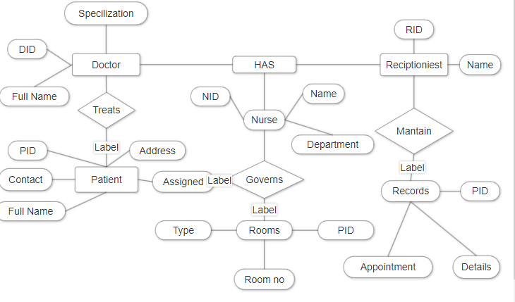

**Data Flow Diagram for HMS**

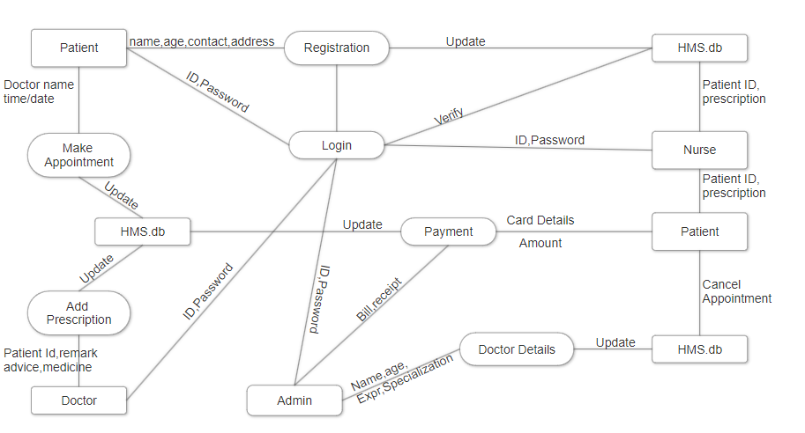

**Flow chart for patient admission**

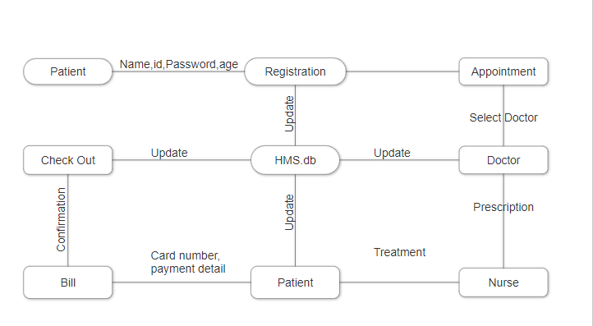

**FUNCTIONAL REQUIREMENTS**

• **Patient Management:**

* Registration of new patients.
* Updating patient demographics.
* Managing patient appointments.
* Maintaining patient medical records.

• **Staff Management:**

* Adding, updating, and removing staff records.
* Assigning roles and permissions.
* Scheduling staff shifts.

• **Appointment Management:**

* Booking, rescheduling, and canceling appointments.
* Notifying patients about upcoming appointments.

• **Billing and Payment:**

* Generating bills for services rendered.
* Processing payments.
* Managing insurance claims.

**NON-FUNCTIONAL REQUIREMENTS**

• **Performance:**

* The system should be responsive and performant even during peak usage times.
* Response times for critical functions should be within acceptable limits.

• **Scalability:**

* The system should be able to handle an increasing number of users, patients, and data volume without significant degradation in performance.

• **Reliability:**

* The system should be reliable, minimizing downtime and ensuring data integrity.
* Backup and recovery mechanisms should be in place to prevent data loss.

• **Security:**

* The system should comply with healthcare data security standards (e.g., HIPAA).
* Access to patient data should be restricted based on roles and permissions.
* Encryption should be used to protect sensitive information during transmission and storage.

**System Requirement:**

1. **Server:** Powerful hardware to host the HMS software and manage the database.
2. **Client Devices:** Desktops, laptops, or tablets with adequate processing power to run the HMS client application.
3. **Operating System:** Server OS (e.g., Windows Server, Linux) and client OS (e.g., Windows, macOS) compatible with the HMS software.
4. **Database:** Relational DBMS (e.g., MySQL, PostgreSQL) for storing and managing HMS data.
5. **Application Software:** HMS suite with modules for patient management, appointment scheduling, billing, etc.
6. **Network:** Reliable LAN infrastructure, internet connectivity, and optionally VPN for remote access.
7. **Security:** Antivirus, firewall, encryption, and access control measures to protect data and systems.

**Usability:**

1. The user interface should be intuitive and easy to use for healthcare professionals with varying levels of technical expertise.
2. Training materials and user manuals should be provided to support users.